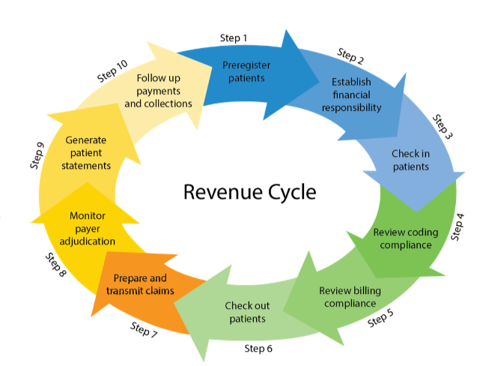

Policy holder

Premiums, health plan

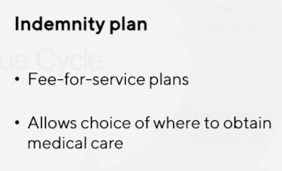

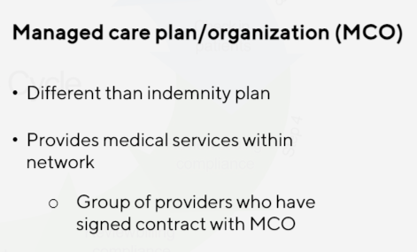

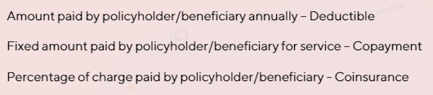

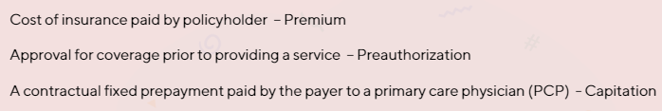

SOFT SKILLS REQUIRED

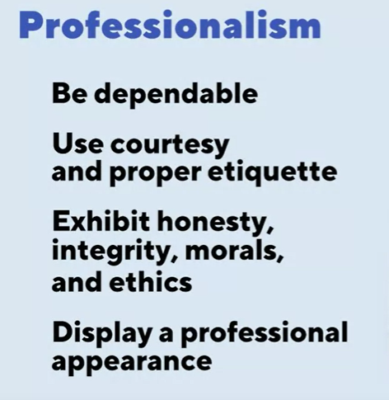



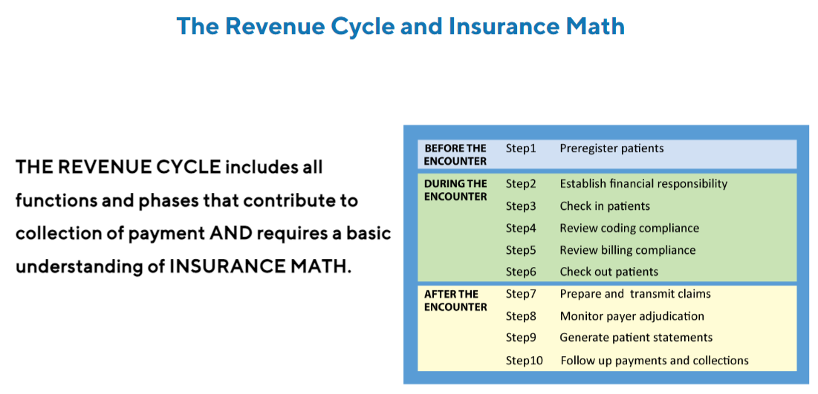

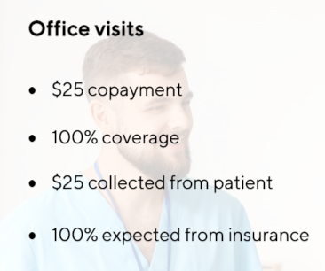

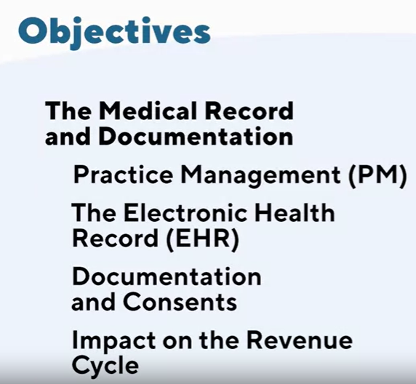

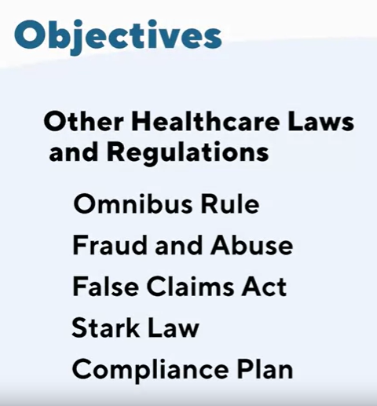



ICD 10 CM: International classification of diseases 10 clinical modifications

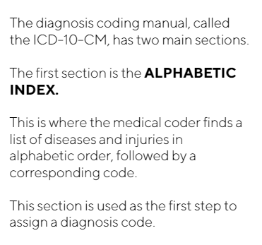

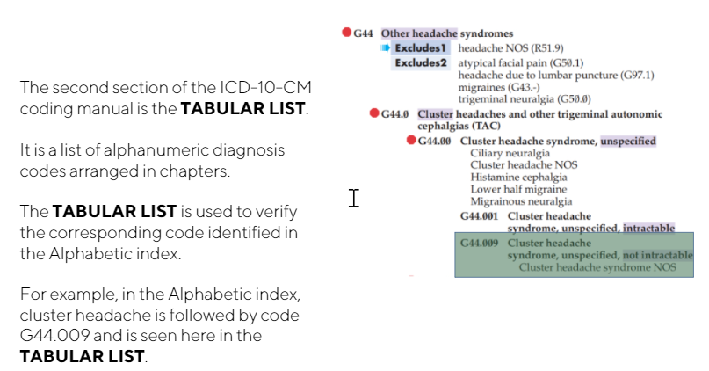

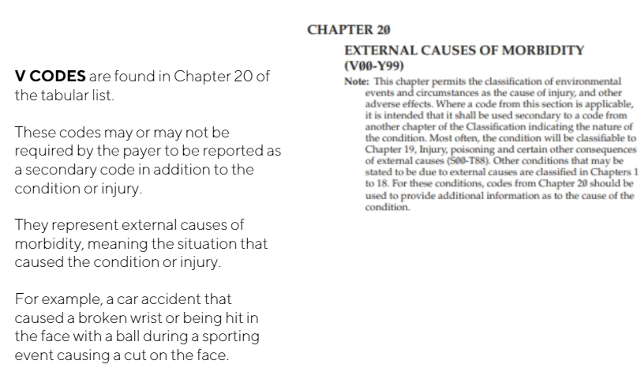

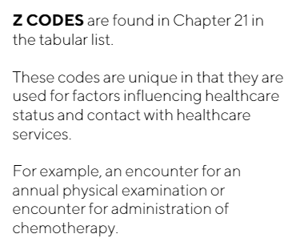

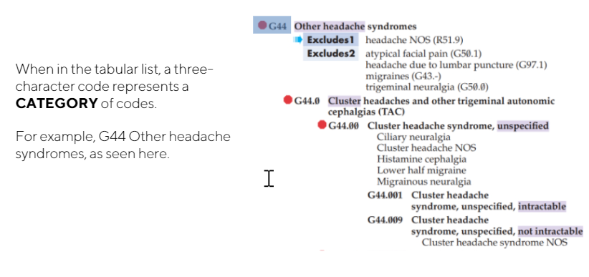

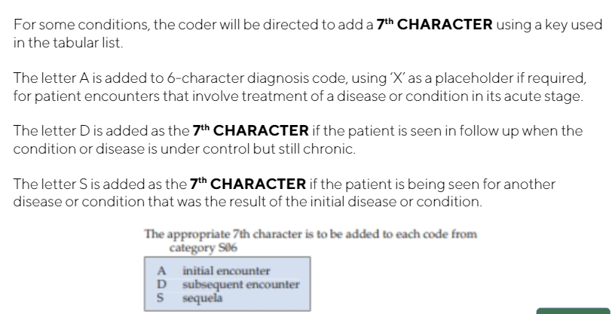

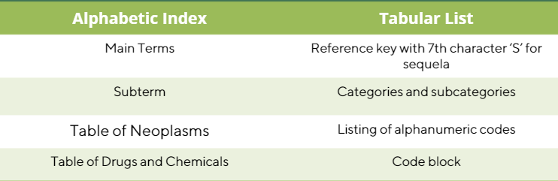

ALPHABETIC INDEX

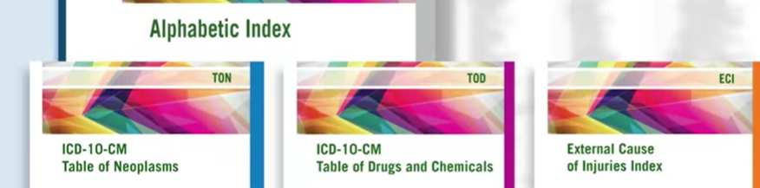

TABULAR LIST: 22 chapters

CPT: current procedural terminology formed by American medical association.

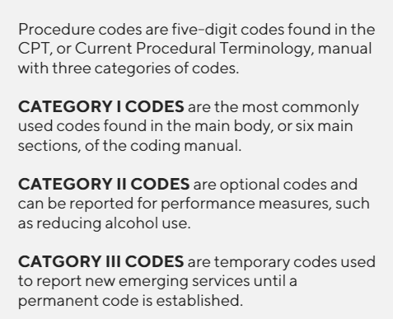

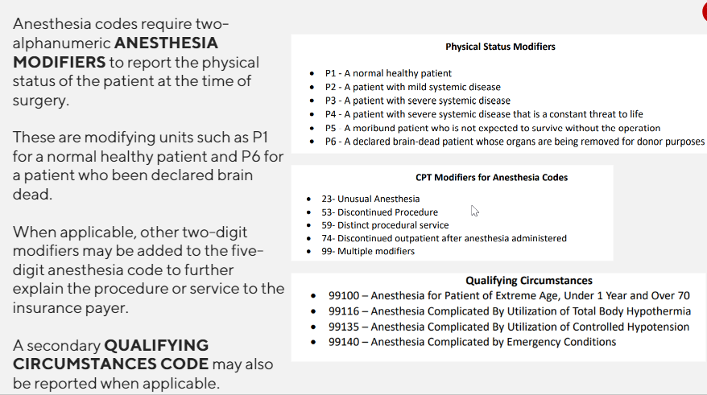

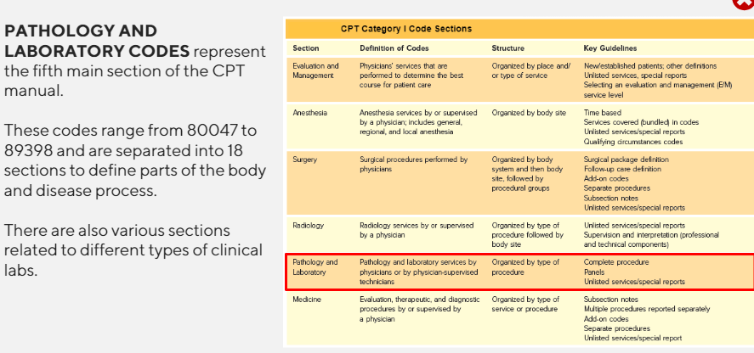

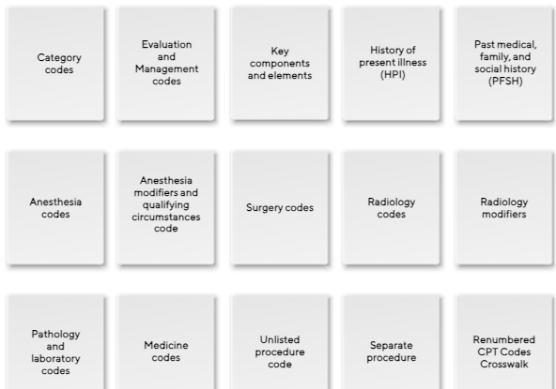

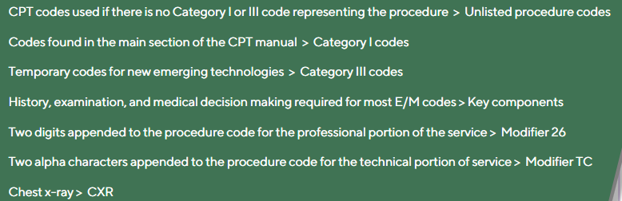

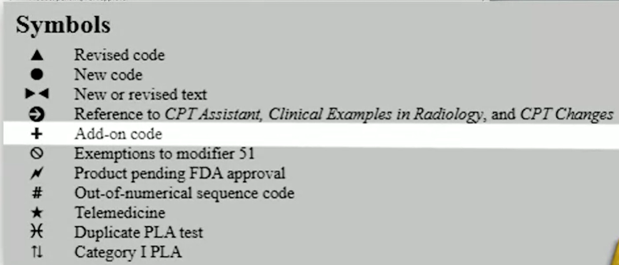

**HCPCS: HEALTH CARE COMMON PROCEDURE CODING SYSTEM**



